SCHOOL NAME: __________________________ EXAMINATION NO: ______________

SOUTH EAST EDUCATION DIVISION
2025 MALAWI SCHOOL CERTIFICATE OF EDUCATION MOCK EXAMINATION

PHYSICS

Subject Number: M162/I
Monday, 31st March Time Allowed: 2 hours
8:00 – 10:00 am

PAPER I

THEORY
(100 marks)

Instructions
Question  Number | Tick if answered | Do not write in these columns
1
2
3
4
5
6
7
8
9
10
11
12
13
- This paper contains 10 printed pages. Please check.
- Before beginning, write your Examination Number at the top of each page.
- This paper contains two sections, A and B. In Section A there are ten short questions while in section B there are three restricted essay questions.
- Answer all the thirteen questions in the spaces provided.
- Use of electronic calculators is allowed.
- The maximum number of marks for each answer is indicated against each question.
- In the table provided on this page, tick against the number of the question you have answered.

© 2025 SEED MOCK Turn over/…

Section A (70 marks)
Answer all the questions in this section

- A student conducted an experiment to find out effect of temperature on solubility of salt. In this experiment give:
- Independent variable.
__________________________________________________ (1 mark)
- Dependent variable.
__________________________________________________ (1 mark)
- Figure 1 is a diagram showing a measuring instrument. Use it to answer the questions that follows.
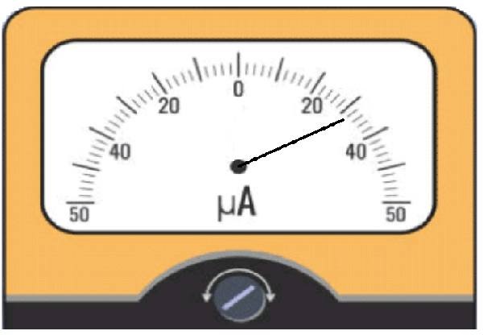
Figure 1
- State any two types of errors associated with instrument shown in figure 1.
___________________________________________________ (1 mark)
- Convert the reading shown in figure 1 to amperes (A).

(1 mark)

- Figure 2 shows effect of magnetic field on nuclear radiation. Use it to answer the questions that follow.
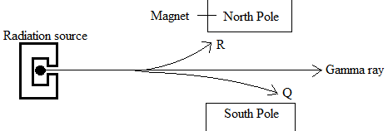
Figure 2
- Identify the type of radiations Q, R and T.
Q: _____________________________________________ (1 mark)
R: _____________________________________________ (1 mark)
- Give any two properties of radiation Q.
______________________________________________________________________________________________________________________________________ (2 marks)
- State any one use of radioactive substances.
________________________________________________________________ (1 mark)
- State any one dangers of radioactivity.
_____________________________________________________________ (1 mark)

- Figure 3 shows a diagram for a hydraulic machine with piston 1 and 2. Use it to answer the questions that follow.
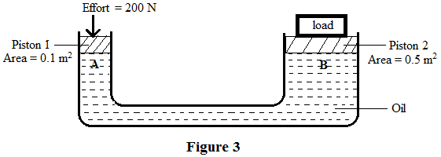
Calculate the:
- Pressure exerted at point A.

(2 marks)
- Force exerted on point B.

(2 marks)

- State the kinetic theory of matter.
______________________________________________________________________________________________________________________________________ (1 mark)
- A gas occupied a volume of 200 cm³ at a temperature of 273 K. Calculate the temperature of the gas if the volume is increased to 300 cm³ at constant pressure.

(2 marks)
- Using the kinetic theory of matter, explain the drying faster of clothes on a sunny day than on a cloudy day.
_____________________________________________________________________________________________________________________________________________________________________________________________________________ (3 marks)

- Figure 4 is a diagram showing a transistor. Use it to answer the questions that follow.
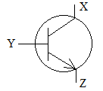
Figure 4
- Name the terminals labelled X and Y.
X: ____________________________________________ (1 mark)
Y: ____________________________________________ (1 mark)
- Give the type of transistor shown in figure 4.
_____________________________________________________________ (1 marks)
- State any one use of transistor in an electric circuit.
_____________________________________________________________ (1 mark)

Continued/…
- Table 1 shows a truth table for NAND gate. Use it to answer questions that follow
Input |  | output
A | B | L
0 | 0 | 1
0 | 1
 | 0 | 1
 | 1 | 0
Table 1
- Complete the table by filling in the missing values. (3 marks)

- Draw the circuit symbol for the NAND gate

(2 marks)
- The energy saver bulb is labelled 240 V, 15 W. Calculate the heat dissipated by the bulb if it operates for 6 minutes.

(3 marks)
- State any two ways of reducing loss of energy in a transformer.
______________________________________________________________________________________________________________________________________ (2 marks)
- Give any one code used to show value of resistance on fixed resistors.
_______________________________________________________________ (1 mark)

Continued/…
- A machine lifts 15 000 N load when an effort of 2 500 N is applied. If the efficiency of the machine is 75%, calculate its:
- Mechanical advantage.

(2 marks)
- Velocity ratio.

(2 marks)
- Define inertia.
______________________________________________________________________________________________________________________________________ (1 mark)
- Explain any one application of principle of moment in everyday life.
_____________________________________________________________________________________________________________________________________ (2 marks)

- a. State any two applications of uniform circular motion in everyday life.
______________________________________________________________ ______________________________________________________________ (2 marks)
b. A particle of mass 3 kg moves with an angular velocity of 10 rad/s along a circular path of radius 20 cm. Calculate its centripetal force.

(2 marks)

Continued/…
- Figure 5 is an incomplete ray diagram showing lens axis of a lens with focal length 60 cm and the principal axis. Use it to answer questions that follow.
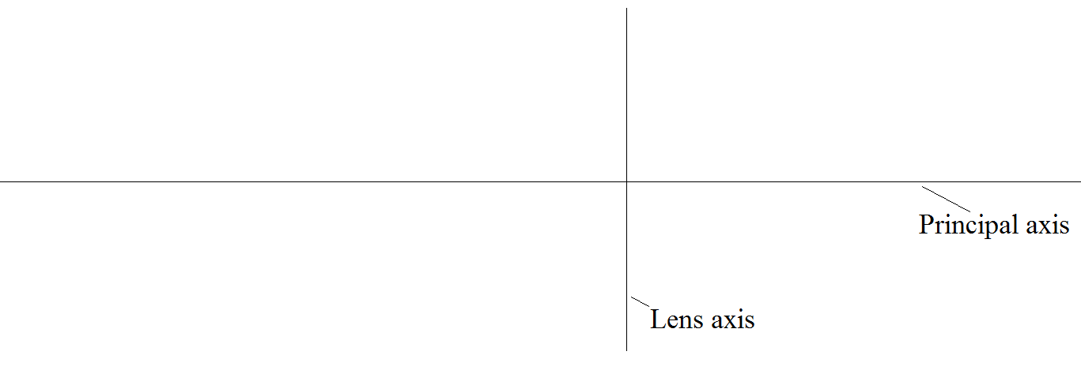
Figure 5
- An object of height 25 cm is placed in front of the lens. Using an appropriate scale complete the ray diagram to show its image. (3 marks)

- Give the position of image formed by the lens using the completed ray diagram for figure 5.
______________________________________________________________________________________________________________________________________ (2 marks)
- Describe the nature of image formed.
_____________________________________________________________________________________________________________________________________ (2 marks)
- Figure 6 is a velocity – time graph showing the motion of a cyclist. Use it to answer questions that follow.
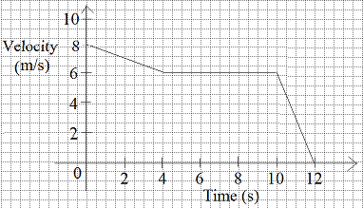
Figure 6
- i. Describe the motion of the cyclist in the first 4 seconds of the journey.
____________________________________________________________________________________________________________________________________ (1 mark)
ii. Calculate the acceleration between 4 seconds and 8 seconds of the journey.

(2 marks)
- Calculate the distance travelled in the last 2 seconds.

(2 marks)
- State Newton’s third law of motion.
______________________________________________________________________________________________________________________________________ (1 mark)
- Figure 4 shows a box of sand of mass 90 kg being pulled constantly for a distance of 6 m on a frictionless horizontal surface by force F.
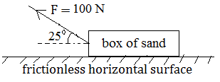
Figure 4
- Calculate the acceleration of the block.

(4 marks)
ii. Calculate the work done on the block.

- marks)
- State any one factor that affects the speed of sound in air.
_____________________________________________________________ (1 mark)
- Figure 7 is a diagram showing a wave. Use it to answer questions that follow.
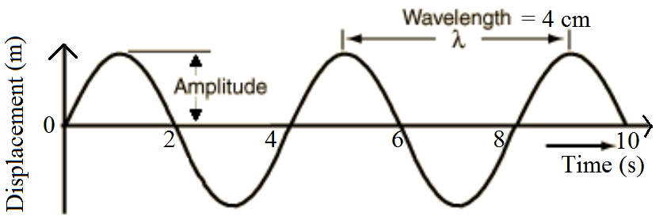
Continued/…
- Calculate the speed of the wave.

(5 marks)
- State any one method of detecting radio waves.
___________________________________________________________ (1 mark)
Section B (30 marks)
Answer all the three questions in this section in an essay form in the spaces provided.
- a. Briefly explain destructive interference.
____________________________________________________________________________________________________________________________________________________________________________________________________________________________________________________________________________________ (4 marks)
b. With the aid of a well labelled diagram, describe the working of a slide
projector.

__________________________________________________________________________________________________________________________________________________________________________________________________________________________________________________________________________________________________________________________________________________________________________________________________________________________________ (6 marks)

- a. Describe the process of shrink fitting of a metal axle on to a metal wheel.
________________________________________________________________________________________________________________________________________________________________________________________________________________________________________________________________________________________________________________________________________________________________________________________________________________________________________________________________________________________________________ (6 marks)
Continued/…
b. Explain the working of an electrical resistance thermometer.
________________________________________________________________________________________________________________________________________________________________________________________________________________________________________________________________________________________________________________________________________________________________________________________________________________________________________________________________________________________________________________________________________________________________________________ (6 marks)

- a. Explain the working of a step down transformer.
__________________________________________________________________________________________________________________________________________________________________________________________________________________________________________________________________________________________________________________________________________________________ (4 marks)
b. With an aid of a well labelled diagram, describe the process used to control
thickness of iron sheets using radiation.

_________________________________________________________________________________________________________________________________________________________________________________________________________________________________________________________________________________________________________________________________________________________________________________________________________________________________ (6 marks)
END OF QUESTION PAPER
NB: This paper contains 10 printed pages

